How to Perform a CS Data Rescue & Rebuild RAID 5

Limitations
- The RAID 5 volume is created by 4 disks.
- Do NOT change the order of the disk cables after the volume has been corrupted.

The main symptoms in this kind of case are:
- No volume and two abnormal disks when booting/waking.
- The four disks are fine and the system log doesn’t point out the exact cause of the disk error. It only shows “Volume [1] is crashed.”

Quickly Rebuild a Temporary Volume to Make a Data Rescue

- Use the official patch to enable telnet, and then login to the CS as root with the admin’s password. First we will use this command line “ mdadm –Sf /dev/md2 ” to stop the RAID 5 data volume “md2”.
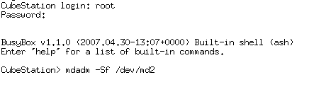
You will see something like this:
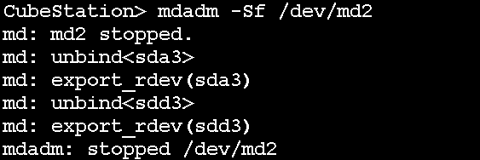

- Then use this command: “ mdadm --assemble --force /dev/md2 /dev/sda3 /dev/sdb3 /dev/sdc3 /dev/sdd3 ” to force the CS to rebuild a RAID 5 volume consisting of only three disks.
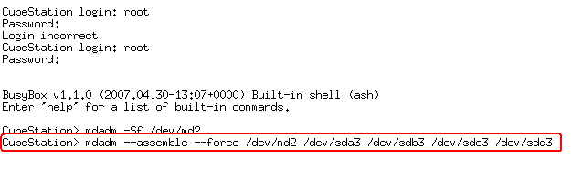

You will see something like this:
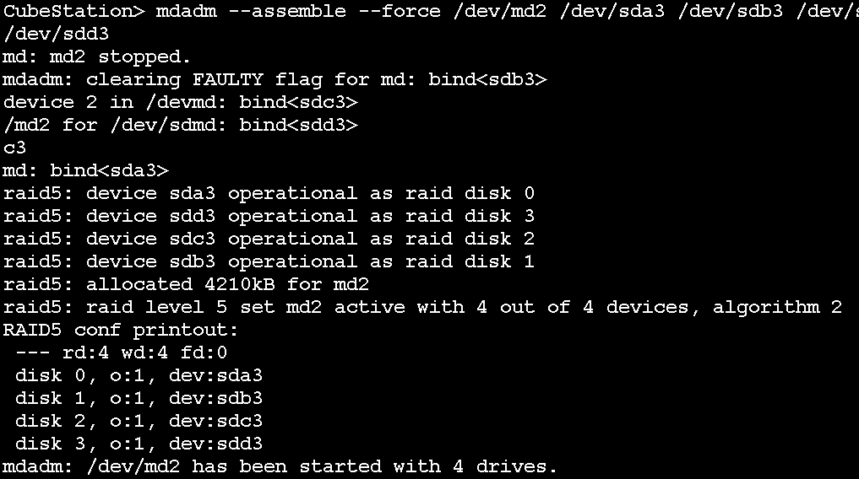

- Reboot the CS and you will see that the volume is back but in degraded mode. Please make a data backup now, and repair the volume after upgrading to firmware v.5xx.
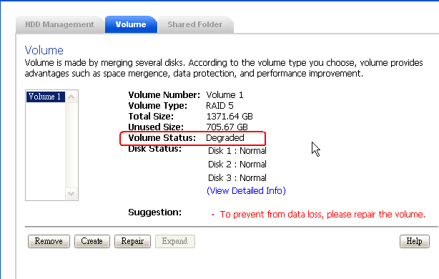

- If this doesn’t work, type the command “ cat /proc/mdstat ” to check which disk is missing as in the following image.
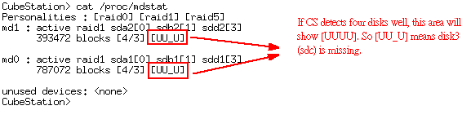

- In this case, the missing disk is disk 3 and you can use the following command to rebuild a RAID 5 volume: “ mdadm –C /dev/md2 –R –L 5 –n 4 /dev/sda3 /dev/sdb3 missing /dev/sdd3 ”

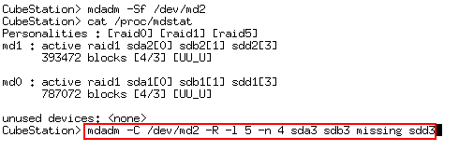

Note: –C (create) , –R (run), -L 5 (Raid Level is 5), -n 4 ( Number of disks is 4)

- Reboot the CS and you will see that the volume is back but in degraded mode. Please make a data backup now, and repair the volume after upgrading to firmware v.5xx.
Force Stop A Volume

- /usr/syno/etc/rc.d/S80samba.sh stop
- /usr/syno/etc/rc.d/S25download.sh stop
- /usr/syno/etc/rc.d/S20pgsql.sh stop
- umount /volume1
- mdadm -Sf /dev/md2

Fsck the volume

==========================start============================
1. stop md2: mdadm -Sf /dev/md2
2. run fsck: fsck.ext3 -pvf /dev/md2 ( if this doens't fsck.ext3 -yvf /dev/md2)
3. mount md2 again: mount -o ro /dev/md2 /volume1
===========================end============================

